# **Inviol Body Camera Project**

# **Proposal Document**

Written by:

Julia Borlase (19078503)

Lingze Meng (19058884)

Ray Crescent Garcia (19058251)

Haoge Ming（18017906）

Sai Gamana Putta (17980983)

## **Table of Contents**

**Inviol Body Camera Project** **1**

**Proposal Document** **1**

Table of Contents 2

Executive Summary 4

Terms of reference (Background Information) 5

Background 5

Inviol 5

Project Aims / Goals 5

The Rationale for the Project 6

Project Importance 6

Existing Systems 6

Key Issues 6

Project Objective and Scope 7

Project Goal 7

Scope 7

Hardware Requirements 7

Architecture / Design Requirements 8

Resources for Inviol Body Camera Project 8

Project Methodology- Project Phases and Practices 10

Planning 10

Learning 11

Project work 11

Team Roles and Expected Work Behavior & Practices 12

Expectations Set 12

Team Contract 12

Team Roles: 13

Meeting Schedule: 13

Schedule and Milestone Report 14

Project schedule (Gantt chart) 14

Milestone Report 15

Definition of Success Factor 16

Several Success factors: 16

Estimate All Costs Incurred 17

Appendix: Disclaimer 18

Appendix 19

Team Roles 19

Team Contract 20

Stakeholder Register 22

Risk Register 23

Work Breakdown Structure (WBS) 24

References 26

## 

## **Executive Summary**

Worldwide, every 7 seconds a workplace injury occurs. Within New Zealand 63% of workplace fatalities are related to motor vehicles, 80% of which can be avoided by proper health and safety measures. In this proposal, we are outlining the implementation of wearable body cameras in the workplace to remove complacency towards safety policies and contribute to making workplaces safer. These cameras that we will research and select will detect breaches of; incorrect use/lack of wearing PPE (personal protective equipment), employees in dangerous areas (around hazardous machinery), and employees jumping off the back of trucks.

Requirements for this project were talked through with the client during an initial brainstorming meeting. The requirements for the camera were split into two categories, being hardware requirements (battery life of the camera, camera resolution, camera size, camera weight), and the architecture/design requirements. For this project, we will be focusing our time on the hardware requirements first and foremost, and work to produce a camera that fits the requirements and has a model that can detect breaches. If time permits, planning towards implementing the models to the camera will be conducted, as well as looking to forward breaches detected by the camera to Inviol’s website.

This project has been broken down into 3 sprints. Sprint 0 focuses on the planning of the project, Sprint 1 focuses on the hardware selection of the camera, Sprint 2 focuses on model training, and Sprint 3 focuses on the final assignment hand-ins and touch-ups to the models.

Milestones have been created and laid out in a logical sequence for the timeline for checkpoints throughout the project, as well as in a logical sequence for the sprints.

The main risks to this project are scope creep, as well as lack of communication between team members. The risk of scope creep comes with any large project that is being undertaken, and our team has to be conscious of the amount of time model training in particular takes and accommodate this in the scope to ensure completion of the project within the time frame given. Communication between the team will be conducted through teams, and meetings are conducted 3 - 4 times a week to ensure communication is constant and everyone is up to date. As the project progresses, the team contract is being updated as more risks are identified to address these.

## **Terms of reference (Background Information)**

### **Background**

Workplace safety practices are vital to ensuring that employees are kept well in and around work sites. Injury in the workplace worldwide occurs every 7 seconds, costing the US $250 billion worldwide annually. Within New Zealand, 63% of fatalities are related to motor vehicles, and 80% of these can be avoided by following health and safety measures correctly. Companies have many policies in place to prevent these accidents from occurring, however, over time people become complacent with these policies (<https://data.worksafe.govt.nz/>).

We are proposing implementing body-worn cameras in the workplace. These cameras will feed feedback to Inviol’s API which will then feed into their website. These cameras that we will research and select will detect breaches of; incorrect use/lack of wearing PPE (personal protective equipment), employees in dangerous areas (around hazardous machinery), and employees jumping off the back of trucks.

### **Inviol**

We will be working with our client Inviol for this project (<https://www.inviol.co.nz/>). Inviol is a startup that is working toward creating safer working environments. This is being done through the implementation of cameras placed on worksites to remove complacency around policies that are known to keep employees safe in the workplace.

We will work with the client throughout the project to discuss and brainstorm the appropriate software and hardware to use for our project.

### **Project Aims / Goals**

This project aims to detect accidents that include;

* Vehicle incidents
* Employees falling from objects
* Being hit by a moving object(s)
* Being hit by a falling object(s)

This project will address these accidents by removing the key factor of complacency. This will be done by providing feedback to employees who are shown through the cameras to be breaking policies. Through this, a conversation will be opened with the managers to provide feedback to the employees and training where needed. This will work with Inviol’s goal of creating safer workplaces and preventing workplace deaths.

## **The Rationale for the Project**

### **Project Importance**

As mentioned in the terms of reference above and in (<https://data.worksafe.govt.nz/>), workplace accidents occur very frequently.

Accountability for these accidents tends to fall on the directors of the companies. If they aren’t able to prove that systems and policies are in place to prevent these accidents, then they are a candidate for charges of manslaughter. These policies can be shown to be in place through the use of these cameras, and with body-worn cameras, more of the workplace and employees will be able to be reviewed to determine causes and consequences. This could help prevent deaths and save companies from charges. The importance of this report to these companies is to provide a solution to these issues and to improve contact between employees and management.

### **Existing Systems**

Body cameras are currently being used in the workplaces of security, law enforcement, emergency services, etc (<https://peoplesafe.co.uk/blogs/body-worn-cameras-and-lone-working/>). This helps provide safety for the employees and allows managers and other parties to review events that have occurred through the employee's view. The purpose of the cameras in most of these workplaces, especially emergency services is to ensure employee safety and can also be used as a prosecution tool against any violence that may occur towards the wearer. As we begin and move through this project, we will be looking to research the current implications of using body-worn cameras in these workplaces.

In comparison to the current cameras that have been implemented in workplaces, our proposed camera will not only provide insight into the safety practices of the employees, and provide evidence of this.

In the future, or if time allows within our project scope to implement the detections into Inviol’s applications, this will also allow quick communication between the employee and site manager to work through the incident and help provide feedback and training where needed.

### **Key Issues**

The issues we will face when finding the optimal camera for our project will be ensuring that the battery life of the camera is long enough to sustain a full workday, as well as the camera API compatibility and wifi compatibility. We will also need to take into account the amount of time that it can take to train and run models for the detection software. The client already has models that we will be able to use and modify, but this will still take the time that will need to be accounted for.

These issues were outlined during a brainstorming session with the client, and with the client and the client's team, we agreed that these issues were ones to note and to keep in mind when researching options for the hardware and software for this project.

## **Project Objective and Scope**

### **Project Goal**

The objective of this project is to implement wearable body cameras in workplaces. Throughout the duration of this project, we will be planning and researching for the optimal camera hardware to use, doing this by comparing possible hardware to the requirements outlined below and be training a model that will detect the outlined dangers that can be performed by employees in a worksite.

Key stakeholders in this project are Inviol and AUT.

### **Scope**

As a team when the project started, we brainstormed the objectives of the project and the goals that we would work towards. These goals were collated with the client's goals during the brainstorming session held with them. If achieved during the project lifespan would deem the project a success, these objectives are;

* A hardware prototype has been selected
* The hardware prototype has basic software installed
* The AI model can detect incorrect employee behavior

To achieve these success criteria we have outlined some hardware and architecture/ design requirements that have been discussed with the client during a brainstorming session.

For this project, we will be focusing our time on the hardware requirements first and foremost, and work to produce a camera that fits the requirements and has a model that can detect breaches. If time permits, once the above objectives have been met, we will also work on the software that will display the detections as a part of Inviol’s website.

### **Hardware Requirements**

1. Camera resolution (pixel resolution): The resolution of the camera will need to be high enough quality to detect employees, their surroundings, and both of these objects moving, but also be at a quality that will not drain the battery.
2. 8-hour battery life: the camera will need to be operational for an average of 8 hours, or a full working day. We will need to take into account the amount of battery capacity a camera has when it comes to selecting the camera for the project so that the camera can run for the amount of time specified, as well as have the computing power for WIFI, GPS and the internal processor.
3. Camera Size and weight: the camera needs to be an appropriate size and weight to be wearable for employees for an entire day, this has been decided with the client to be 500g or less.
4. Minimum performance models: these models for the hardware could include; jetson, raspberry pi, object detector, position estimation, etc. These are options that were discussed with the client and will be in accompaniment with the camera itself.
5. Onboard and post-processing, processing will either be done onboard or in post-processing, this will be determined by the requirement of how much battery power the processing takes, and how much more weight onboard processing will require.

### **Architecture / Design Requirements**

1. Send messages through the internet: the camera will need software that will send messages/ videos from the hardware to Inviol’s API.
2. Detect objects: the software will need to be able to have an object detection element to identify the employee's actions and views.
3. Open source repos: as advised by the client, we will resource open source repositories for model training.

Derived from our definition of success and the hardware and architecture/design requirements stated above, our project deliverables are formed. These deliverables consist of;

1. Wearable body cameras
2. Model training to be completed for detection

As seen in the requirements stated in the scope, our team will need several resources to complete this project defined by our definition of success.

### **Resources for Inviol Body Camera Project**

| Body-Worn Camera | Not yet acquired |
| --- | --- |
| Camera Harness | Not yet acquired |
| Camera processor | Not yet acquired |
| Camera lens (if needed differ from the camera) | Not yet acquired |
| YOLO detection software + upskilling training | Acquired, provided by the client |
| Software API | Acquired, provided by the client |
| Azure Software | The client has the azure software and during the brainstorming meeting agreed-upon allowing us to use it. Allows for sprint planning and management |

## 

## **Project Methodology- Project Phases and Practices**

### **Planning**

1. Our main goal as a team was to take a real-world topic and conduct an in-depth investigation focusing on the type of accidents that usually occur around trucks in order to assist Inviol in removing complacency from workplaces thus making workplaces safer.
2. As a team, we will be working with the clients from the very beginning of the project to brainstorm and discuss the appropriate software and hardware to use for the project that will help create a safer workplace with body-worn cameras
3. We receive information and instructions from our clients on how to set up a body-worn camera that connects to an API and feeds data to Inviol’s website that is assessed by site managers who can view accidental actions by the employees.
4. While in the process of creating the product for Inviol as a whole team we will be composing a draft proposal noting down all the requirements for the project which is signed individually to all the team members to be completed.
5. Once the draft proposal is completed and handed over to receive feedback. We will contact our client and plan a meeting in order to start with creating our product for the company as a part of our main project.
6. Identifying the features that our camera needs to detect would be the first step in creating a safer work environment for employees.This would include Location, positioning rules that enables to have wifi, Bluetooth, GPS which detects in advance the accidents that can occur. This will also include the behavior of a human that can detect any unsafe behavior such as incorrect use of PPE, being around dangerous machinery, and jumping.
7. Once the necessary detection is completed, Hardware requirements need to be noted down. This would include Camera resolution (pixel resolution), 8-hour battery life: ensuring that the camera has plenty of power to run for as long as stated, as well as be equipped with WIFI, GPS, and an internal processor, Camera size, and weight: employees need to be able to wear the camera for a long time, Minimum performance model, Onboard processing or post-processing, depending on how much battery power the processing takes and how much weight onboard processing requires.
8. The next step would be starting model training. As requested by the client, the Object detection feature of the YOLO software that will be installed onto the hardware prototype should be able to detect employee actions.
9. The next step of planning would be researching open-source repos: a recommendation from the client will allow us to use open source repositories for model training.
10. The most important planning step is the building process of the model camera product with all the hardware and Architecture / Design Requirements. This includes Azure DevOps software, Yolo detection software Prioritization, Break Down Work into User Stories, Workload, Estimated Time Of Completion, Description of the model created, Team Member(s) Assigned to User Story, Exceptions/Criteria, Set Sprint Goals of completing the product on time.
11. Testing would be a very crucial step that involves the client to test the product we have created and make sure all the applications related to the product and up and running which will help with creating the workplace safer for the employees
12. Passing all these steps we have planned would create a successful body-worn camera model which will complete our project work and help create a safer workplace for the employees and to cause fewer accidents at work.

### **Learning**

Learning is a very essential part of the project in every step to lead to great successful teamwork. Our team's main focus was to learn to develop body-worn cameras in the workplace, as well as learn how to train models for the cameras. By using such cameras, you will be able to detect items such as employees wearing the incorrect clothing, jumping off and over hazardous surfaces, employees working in potentially dangerous areas, incorrect use of personal protection equipment, etc. In this process, we will be learning how cameras work and how the API will feed the video data to Inviol’s website application by observing Inviol’s current cameras and API. First, we will mainly be focusing on selecting and creating the camera’s hardware. Through this, we will also be learning the best-fit camera for the creation in accordance with its weight, size, battery life, and resolution of picturization. Will be learning to install the software in the body-worn cameras which would include features such as wifi, Bluetooth, and GPS. We will also be learning how to train the models to be installed on the camera, this learning will predominantly be done through workshops with the client, and during workshop hours as a team.

### **Project work**

Our main project work is based on working with our client Inviol for this project. Inviol is a New Zealand-based startup developing company AI-driven hardware & software solutions to assist in detecting workplace hazards as well as implementing workplace health & safety strategies to prevent accidents from occurring. Worksite cameras are being installed in an effort to weed out complacency surrounding policies that are known to keep employees safe around the workplace and decrease the possibility of accidents. It takes a considerable amount of effort for agencies to get body cameras into place. Implementing body-worn cameras has some challenges, including monetary and personnel resources. Keeping all this in mind our team has collaborated with Inviol for this project work of creating a body-worn camera product to provide employees with the feeling of safety at work with the camera serving as a safeguard against accidents occurring with members of the public and providing evidence should an incident occur.

## **Team Roles and Expected Work Behavior & Practices**

### **Expectations Set**

We have created a contract as a team so that we would know what is expected of us and each other when working together. The terms of the contract focus on values such as good communication, proper conflict handling, and professionalism. This ensures that our progress throughout the project will be smooth as long as we follow the terms that we all agreed on.

### **Team Contract**

* Communication with team members: team members will speak politely and respect each other, and will not lower their voice or their opinions. All the team members will be positive in recognizing and thanking one another's thoughts on the team project and will not be speaking down to each other. Team members should acknowledge and thank each other for the contributions they make to the team project.
* Seeking help from team members: Be honest with ourselves when we are stuck and accept help from other team members. Allow members to provide assistance when we are stuck.
* Team meetings: All team members must listen attentively without interjecting while an individual team member is sharing their thoughts and ideas. During conversations, there should be no disagreements. All team members must attend all the meetings and adhere to the rules that govern effective meetings. Attending meetings prepared by members of the meeting group should be punctual.
* Interpersonal Disputes within Team Members: Team members will ensure they all understand what to communicate and when. Any complaints regarding other team members will be addressed first within the team, if a solution can not be found, we will communicate our issues with the teacher for assistance.
* Team problem solving, conflict resolution, and decision making: disputes among teammates will be handled directly with the disputants. It is important to not hold grudges against one another and work together as a group leading to achieving success.
* Team leadership: We are a team of 5 members and treat all team members equally hence leadership will rotate weekly as per the work done that has been provided to the individual by the group.

### **Team Roles:**

| **Member** | **Roles** |
| --- | --- |
| Julia | Front end  App design  API |
| Ray | Developer  Wanting to learn AI Model Training |
| Gamana | Hardware installment  Creating a website |
| Lingze Meng | Information collection  Programming Language  Testing |
| Haoge Ming | Project schedule making  Information collection  Testing |

### **Meeting Schedule:**

Team Meetings - Wednesday/Friday 4:00 pm - 5:00 pm

Mentor Meetings - Tuesday

Client Meetings - Tuesday

## **Schedule and Milestone Report**

### **Project schedule (Gantt chart)**

### 

### **Milestone Report**

| **Milestone** | **Status** | **Responsible** | **Issues/Comments** | **Deadline** |
| --- | --- | --- | --- | --- |
| Sprint 0 Begins | Ongoing | All Members | Beginning of the first spring | 2022/04/26 |
| Team Contract | Completed | All members | Team Contract Draft Finalized | 2022/03/05 |
| Timeline | Completed | Julia Borlase | Timeline throughout the process of the project | 2022/03/05 |
| Meeting minutes | Ongoing | Julia Borlase | Recorded all the information about each time meeting | 2022/03/10 |
| Proposal written report | Completed | All members | Assigned work to each member | 2022/03/29 |
| Present proposal | Doing | All members | Proposal presented to the moderator and mentor | 2022/04/08 |
| Updated Proposal | Doing | All Members | Updated proposal due from feedback from the proposal presentation | 2022/04/22 |
| Sprint 1 Begins | Planning | All Members | Sprint 0 to be completed.  Sprint 1 will focus on the selection of hardware for the camera and will result in the finalized prototype for the camera + and upskilling for our team in model training. | 2022/06/05 |
| Hardware Research | Doing | All Members | Researching possible hardware and discussing these options with the client | 2022/05/14 |
| Select Hardware | Doing | All members | Base camera to have been researched and selected | 2022/05/14 |
| Selected Hardware Parts (if required) | Planning | All members | Extra parts that the camera might need to be modified to be researched and selected | 2022/05/14 |
| Upskilling | Planning | All Members + Client | To be done with the client during workshops and practice during worksite hours as a team. | 2022/06/06 |
| Finalized Camera, Camera Parts, and Set-Up | Planning | All Members | This milestone is the date that we will need to have the camera prototype functional for test footage, including having the camera and all the parts ready to go | 2022/05/29 |
| Test Footage | Planning | All Members | Collecting test footage to train the models off with camera hardware | 2022/06/03 |
| Mid-term progress review | Planning | All members | Check the work process, assignment due date. | 2022/06/03 |
| Sprint 2 Begins | Planning | All Members | Sprint 2 will focus on model training and achieving training for the three detections we want our camera to achieve during this project | 2022/09/05 |
| Model-Training Begins | Planning | All Members | Training of the models for the detections identified in Sprint 0 and 1 to begin using test footage | 2022/06/07 |
| First Detection | Planning | All Members | The first model will be trained and will be detecting incorrect use of PPE (personal protection equipment) | 2022/07/18 |
| Second Detection | Planning | All Members | The second model will be trained and will be detecting employees in dangerous areas / too close to dangerous equipment | 2022/08/15 |
| Third Detection | Planning | All Members | The third model will be trained and detect jumping off trucks | 2022/09/05 |
| Final Sprint | Planning | All Members | The final sprint will focus on finalizing the hardware prototype and models, as well as final assignment hand-ins | 2022/11/11 |
| Final Product | Planning | All members | Final product due for assignment hand in | 2022/11/11 (TBC) |
| Poster | Planning | All members | Poster due for assignment hand in | 2022/11/11 (TBC) |
| Portfolio | Planning | All members | All the documents are included in the google drive, the due date for assignment hand in | 2022/11/11 (TBC) |

### **Definition of Success Factor**

Success factors are a set of components that determine the quality and schedule of a project. In addition, the success factor is also the criterion for judging a project, and it is also an indispensable component in every project. The development of a project needs to be based on sufficient success factors.

**How to Identify a Success factor:**

* **Accurately define and communicate project goals.**

Make sure every stakeholder understands why this goal is important.

* **Understand the scope of the project**

Identify task dependencies and set priorities. Create a project scope statement and make sure all the stakeholders understand it.

* **Communication**

Communicate with the team and also need to keep different team members informed on things related to their tasks.

* **Manage risks**

Identify as many risks as possible during the project planning phase. Strive to understand root causes, and how they could affect project success.

### **Several Success factors:**

**1: Methodical Approach**

The selection of an appropriate project management technique is critical to success. Follow the patterns and approaches of the framework selected to make sure the process is clear, dependable, and efficient. All stakeholders should be aware of the need of devoting time to defining a clear project goal and agree to do so.

**2: Proper Planning**

Developing a detailed schedule can help the team know the exact progress of their projects. Relying on this schedule allows the team to reasonably allocate sufficient time for each task to be completed. This ensures the efficiency of the entire project.

**3: Effective Communication**

Effective communication can drive the enthusiasm of each team member, and can accelerate the development progress of the entire project.

**4: Sense of responsibility**

Each team member has their own value. In the process of teamwork, everyone should be clear about his own task and be responsible for it. The sense of responsibility from everyone is the key to the achievement of a team, only in this way can guarantee the quality of every part of the project.

## 

## 

## 

## 

## 

## 

## 

## 

## 

## 

## **Estimate All Costs Incurred**

Below is a layout of the cost estimate. At this stage in the project, due to camera hardware not being selected it is not possible to determine the final cost estimate of the project. The client has agreed, during our initial meeting, to provide their licensed software, servers, and software development tools to our team to utilize.

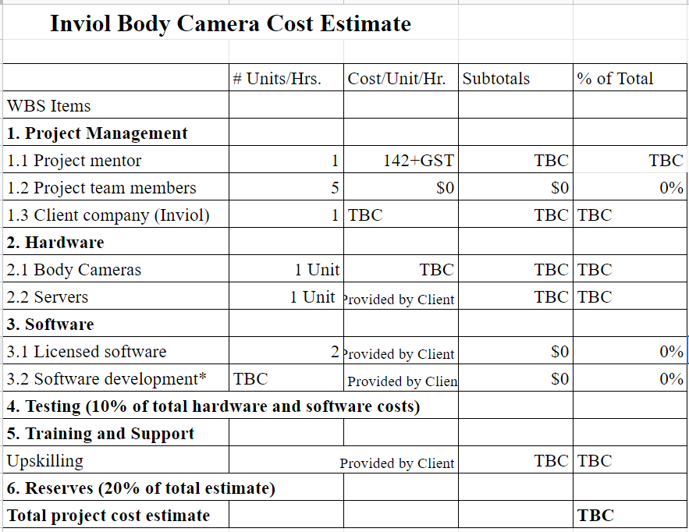

## **Appendix: Disclaimer**

**Disclaimer:**

**Clients should note the general basis upon which the Auckland University of**

**Technology undertakes its student projects on behalf of external sponsors:**

*While all due care and diligence will be expected to be taken by the students, (acting in software*

*development, research or other IT professional capacities), and the Auckland University of Technology, and student efforts will be supervised by experienced AUT lecturers, it must be recognised that these projects are undertaken in the course of student instruction. There is therefore no guarantee that students will succeed in their efforts.*

*This inherently means that the client assumes a degree of risk. This is part of an arrangement,*

*which is intended to be of mutual benefit. On completion of the project it is hoped that the client*

*will receive a professionally documented and soundly constructed working software application,*

*some part thereof, or other appropriate set of IT artifacts, while the students are exposed to live*

*external environments and problems, in a realistic project and customer context.*

*In consequence of the above, the students, acting in their assigned professional capacities and the Auckland University of Technology, disclaim responsibility and offer no warranty in respect of the “technology solution” or services delivered, (e.g. a “software application” and its associated documentation),both in relation to their use and results from their use.*

## **Appendix**

### **Team Roles**

| **Member** | **Roles** |
| --- | --- |
| Julia | Major: Software Development   * Front end * App design * Wanting to learn API |
| Ray | Major: Software Development   * Developer * Wanting to learn AI Model Training |
| Gamana | Major: Computational intelligence   * Hardware * Creating a website |
| Lingze Meng | Major: Computational intelligence   * Information collection * Programming Language * Testing |
| Haoge Ming | Major: IT Service Science   * Project schedule making * Information collection * Testing |

### **Team Contract**

**Project Team Members Names and Sign-off:**

| **Name** | **Sign-off on Team Contract** |
| --- | --- |
| **Julia Borlase** |  |
| **Sai Gamana Putta** | **Gamana** |
| **Ray Crescent Garcia** |  |
| **Lingze Meng** | **Lingze Meng** |
| **Haoge Ming** | **Haoge** |

**Code of Conduct:** As a project team, we will:

* Communication with team members - team members will speak politely and respect each other, will not lower their voice or their opinions. All the team members will be positive in recognizing and thanking one another's thoughts on the team project, and will not be speaking down to each other. Team members should acknowledge and thank each other for the contributions they make to the team project.
* Seeking help from team members - Be honest with ourselves when we are stuck and accept help from other team members. Allow members to provide assistance when we are stuck.
* Team meetings: All team members must listen attentively without interjecting while an individual team member is sharing their thoughts and ideas. During conversations, there should be no disagreements. All team members must attend all the meetings and adhere to the rules that govern effective meetings. Attending meetings prepared by members of the meeting group should be punctual.
* Team members’ communication with other teammates and including teacher- teammates will ensure they all understand what to communicate and when. Any complaints regarding team members will be addressed first in the team and try to solve it if it is not solved, we communicate with the teacher for help.
* Team problem solving, conflict resolution, and decision making - disputes among teammates will be handled directly with the disputants. It is important to not hold grudges against one another and work together as a group leading to achieving success.
* Team leadership - We are a team of 5 members and treat all team members equally hence leadership will rotate weekly as per the work done that has been provided to the individual by the group.

**Participation:** We will:

* Treat the project with a creative mind and a positive attitude to discuss.
* Respecting each member’s idea and measuring the balance produce the final answer.
* Accept any idea and analysis rationally together.

**Communication:** We will:

* Discuss and consider any ideas given by a team member.
* Not be afraid to ask each other for help and to be willing to help one another when needed.
* Give each other effective feedback and be welcoming of criticism.

**Problem Solving:** We will:

* Try to encourage people to actively express their opinions to solve problems so that we can see the problem from different perspectives to solve it better
* Combining everyone's ideas through the discussion, get a solution that everyone is satisfied with, and may also come up with better ideas in the process of discussion
* Referring to other similar cases and using data to help solve the problem, we can learn from other people's experiences and combine our own ideas to solve problems.
* Always be patient and find the best solution for the problem

**Meeting Guidelines:** We will:

* Attend all scheduled meetings, and communicate with the team if you can not attend. This will allow the team to keep members that can’t make it up to date.
* Be focused during meetings, while meetings are online, act and engage as if you were in person.
* Be involved in group discussions, and communicate your progress and ideas to the team so everyone is up to date with the whole project.
* Stay on task during meetings and follow the plans set out in the timeline in the team portfolio.

### **Stakeholder Register**

| **Name** | **Position** | **Internal/External** | **Project Role** | **Contact Information** |
| --- | --- | --- | --- | --- |
| Tane Van Der Boon | Inviol CEO | External | Client | [tane@inviol.com](mailto:tane@inviol.com) |
| Paul Lee | Inviol employee | External | Client | [paul@inviol.com](mailto:paul@inviol.com) |
| Roopak Sinha | AUT Lecturer | Internal | Mentor | [roopak.sinha@aut.ac.nz](mailto:roopak.sinha@aut.ac.nz) |
| Ramesh Lal | AUT Lecturer | Internal | Lecturer | ramesh.lal@aut.ac.nz |
| Sai Gamana Putta | Team Member | Internal |  | [qhk6472@autuni.ac.nz](mailto:qhk6472@autuni.ac.nz) |
| Ray Crescent Garcia | Team Member | Internal |  | [ffc9080@autuni.ac.nz](mailto:ffc9080@autuni.ac.nz) |
| Lingze Meng | Team Member | Internal |  | [hnc8343@autuni.ac.nz](mailto:hnc8343@autuni.ac.nz) |
| Haoge Ming | Team Member | Internal |  | [tfp3422@autuni.ac.nz](mailto:tfp3422@autuni.ac.nz) |
| Julia Borlase | Team Member | Internal |  | [zqj5293@autuni.ac.nz](mailto:zqj5293@autuni.ac.nz) |

### **Risk Register**

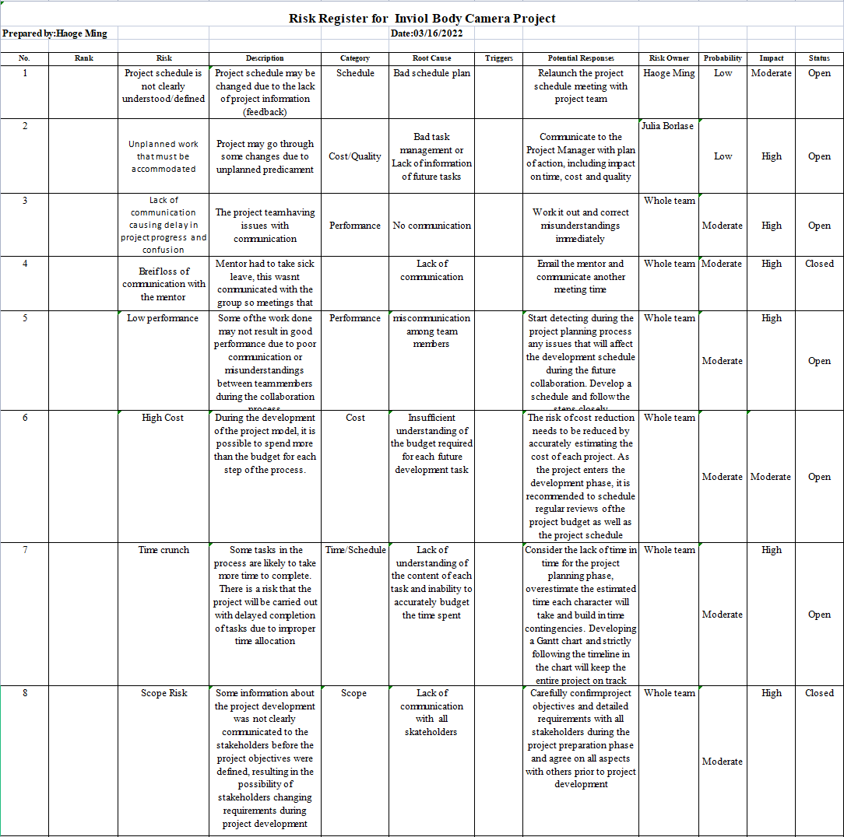

### 

### **Work Breakdown Structure (WBS)**

**1.0** Main category :Research

1.1 Subcategory: Collect customer requirements (client meeting)

1.1.1 Subcategory: Collect background information about client’s companies

1.1.2 Subcategory: Understand the rationale for the project

1.1.3 Subcategory: Understand clients expectation for our future work

1.1.4 Subcategory： Understand customer expectations and requirements for products (hardware and software)

1.2 Subcategory： Define detection content

1.2.1 Sub-subcategory: Hard Hats/HighVis/PPE/Glasses/Masks

1.2.2 Sub-subcategory： Detects Location

1.2.2.1 Sub-subcategory: Bluetooth/Wifi/GPS

1.3 Subcategory: Defining unsafe behavior in workspace

1.3.1 Subcategory：Define a model or library that detects location

1.3.2 Subcategory: Learn about the types of APIs and their different functions

1.3.3 Subcategory: Body Position

1.3.4 Subcategory: Lifting/Running/Jumping

**2.0** Main category : Hardware

2.1 Subcategory: Camera requirements

2.1.1 Sub-subcategory: Camera Resolution

2.1.2 Sub-subcategory：Battery life

2.1.3 Sub-subcategory: Wifi/Bluetooth/GPS available

2.1.4 Sub-subcategory: Performance processor

2.1.5 Sub-subcategory: Camera Chips research

2.2 Subcategory: Use either Live Detection or Recording to train the model

2.3 Subcategory: Performance Models

2.3.1 Subcategory： Camera Resolution

**3.0** Main category :Architecture

3.1 Subcategory: Messages sending

3.2 Subcategory: Object Detection

3.3 Subcategory: Framerate

3.4 Subcategory: Programming Language

3.4.1 Sub-subcategory:APP development

3.4.1.1 Sub-subcategory: API Mode

3.3.2 Sub-subcategory: Product Design

3.3.3 Sub-subcategory: Graphic Design

3.3.4 Sub-subcategory: UX Design

3.3 Subcategory: Open Source Repos

**4.0** Main category : Building

4.1 Subcategory: Agile software development

4.1.1 Sub-subcategory: Sprints

4.2 Subcategory: Consider the priority of sub-projects

4.3 Subcategory: Break Down Work into User Stories

4.4 Subcategory: Estimated Time Of Completion

4.5 Subcategory：Set Sprint Goals

**5.0** Main category : System Testing and Evaluation

5.1 Subcategory: Data test

5.2 Subcategory: Hardware test

5.2.1 Sub-subcategory: Body camera

5.3 Subcategory: System Operation test

### **References**

(n.d.). Data Centre | WorkSafe. <https://data.worksafe.govt.nz/>

(n.d.). Inviol. <https://www.inviol.co.nz/>

*Body worn cameras and lone working*. (2022, February 18). Peoplesafe. <https://peoplesafe.co.uk/blogs/body-worn-cameras-and-lone-working/>

Sidorenko, A. (2018, September 25). *Bloc architecture in flutter: A modern architectural approach and how we use it at Jimdo*. Medium. <https://medium.com/@artemsidorenko/bloc-architecture-in-flutter-a-modern-architectural-approach-and-how-we-use-it-at-jimdo-bea143b56d01>